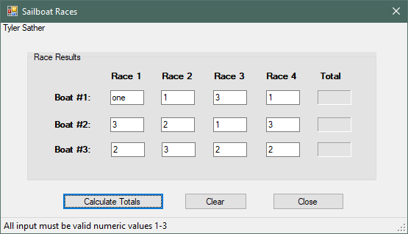

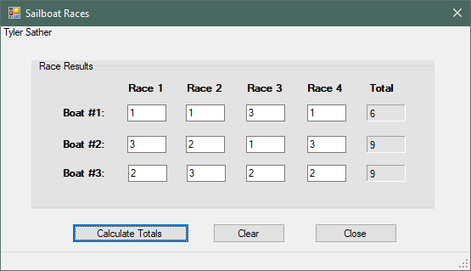

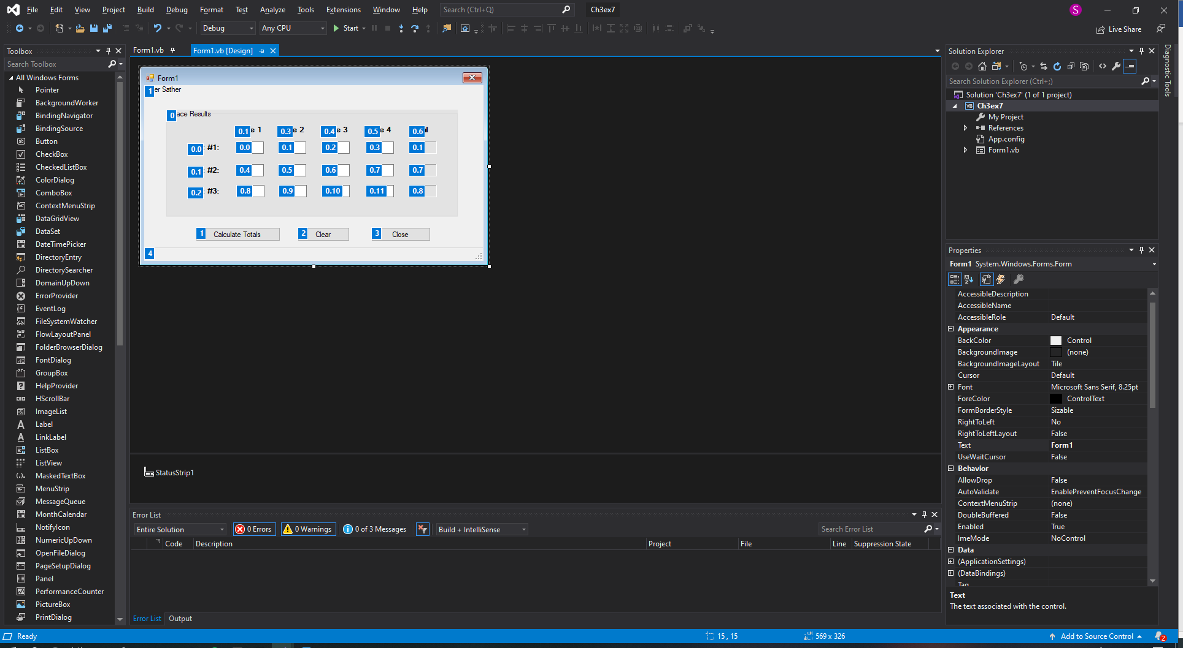

***********Main Forms code

Public Class Form1

Private Sub btnCalc_Click(sender As Object, e As EventArgs) Handles btnCalc.Click

'Declare variables for calculations.

Dim intB1T As Integer

Dim intB2T As Integer

Dim intB3T As Integer

'Clears Status Strip of any previous error message.

lblStatus.Text = String.Empty

Try

'Calculate Boat 1's total

intB1T = CInt(txtB11.Text) +

CInt(txtB12.Text) +

CInt(txtB13.Text) +

CInt(txtB14.Text)

lblB1T.Text = intB1T.ToString()

'Calculate Boat 2's total

intB2T = CInt(txtB21.Text) +

CInt(txtB22.Text) +

CInt(txtB23.Text) +

CInt(txtB24.Text)

lblB2T.Text = intB2T.ToString()

'Calculate Boat 3's total

intB3T = CInt(txtB31.Text) +

CInt(txtB32.Text) +

CInt(txtB33.Text) +

CInt(txtB34.Text)

lblB3T.Text = intB3T.ToString()

Catch

'Error Message

lblStatus.Text = "All input must be valid numeric values 1-3"

End Try

End Sub

Private Sub btnClear_Click(sender As Object, e As EventArgs) Handles btnClear.Click

'Clear all input fields

txtB11.Clear()

txtB12.Clear()

txtB13.Clear()

txtB14.Clear()

txtB21.Clear()

txtB22.Clear()

txtB23.Clear()

txtB24.Clear()

txtB31.Clear()

txtB32.Clear()

txtB33.Clear()

txtB34.Clear()

'Clear all output fields

lblB1T.Text = String.Empty

lblB2T.Text = String.Empty

lblB3T.Text = String.Empty

lblStatus.Text = String.Empty

'Reset the Focus Field

txtB11.Focus()

End Sub

Private Sub btnClose_Click(sender As Object, e As EventArgs) Handles btnClose.Click

'Closes the form

Me.Close()

End Sub

End Class